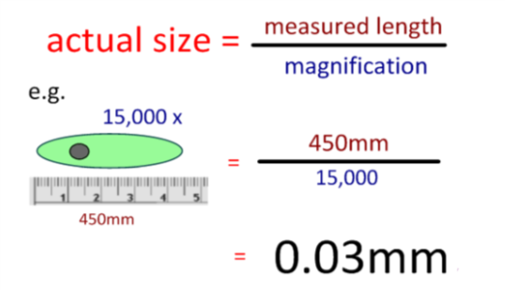
Microscopy – Calculating actual size

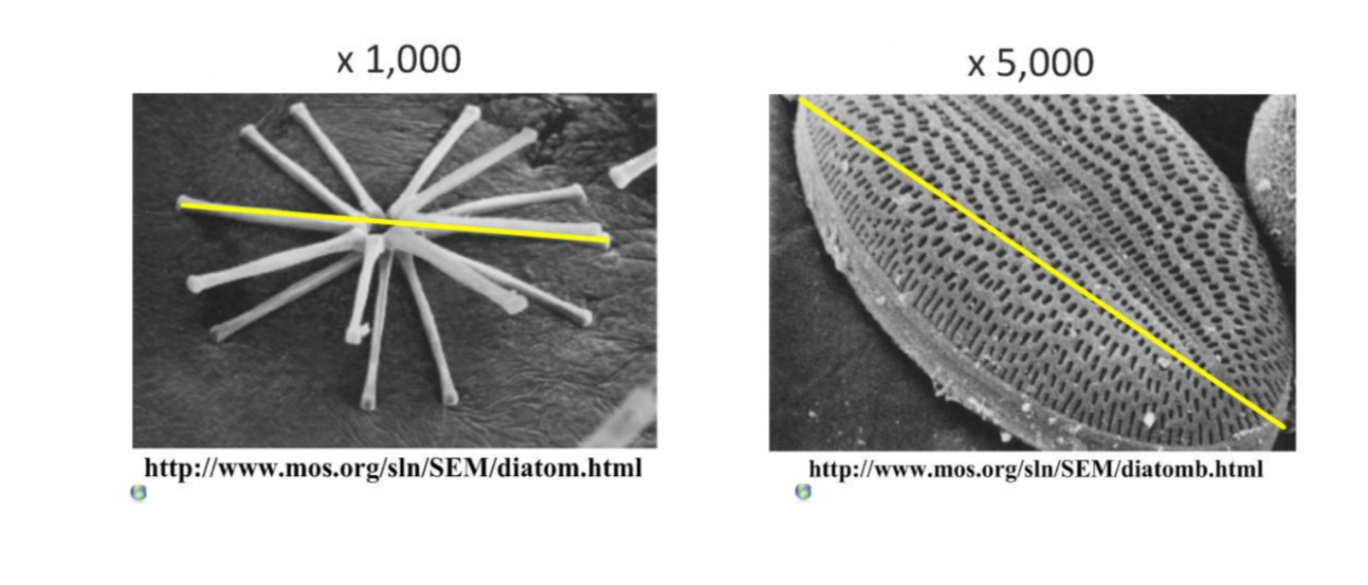
- Calculate the actual size of these images
- Imagine you saw this cell in the microscope at 400x magnification. Draw a labelled scientific diagram of one cell below. Remember to include an accurate scale.
